1. 1721

select truck.truck_id, customers.customer_id

from truck

inner join trucking_truck on truck.truck_id = trucking_truck.truck_id

inner join locationn on locationn.location_id = trucking_truck.location_id

inner join package on package.location_id = locationn.location_id

inner join transaction_report on transaction_report.package_id = package.package_id

inner join customers on customers.customer_id = transaction_report.customer_id

where truck.truck_id = 1721

group by truck.truck_id, customers.customer_id

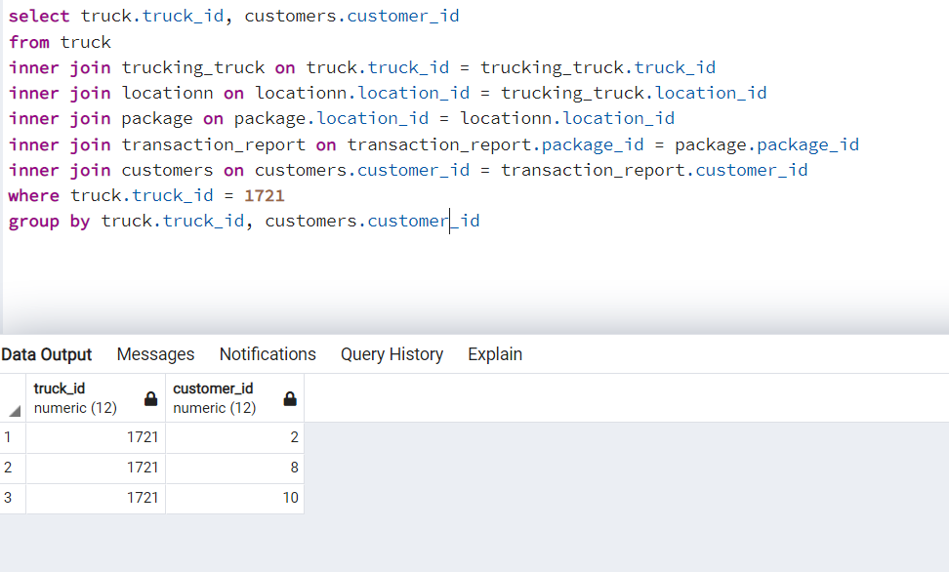

1. Most packages

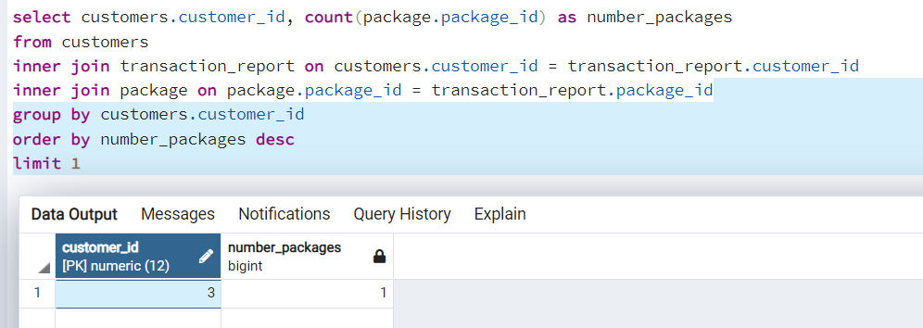

select customers.customer_id, count(package.package_id) as number_packages

from customers

inner join transaction_report on customers.customer_id = transaction_report.customer_id

inner join package on package.package_id = transaction_report.package_id

group by customers.customer_id

order by number_packages desc

limit 1

1. The most money

select customers.customer_id, sum(orders.price) as total

from customers

inner join orders on customers.customer_id = orders.customer_id

group by customers.customer_id

order by total desc

limit 1

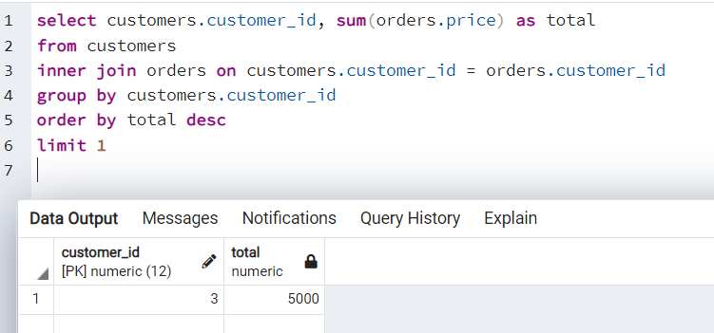

1. The most street

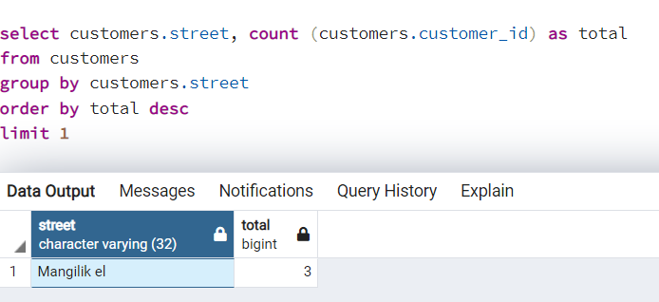

select customers.street, count (customers.customer_id) as total

from customers

group by customers.street

order by total desc

limit 1